**YARN**

**Student Name: Nabh Sanjay Mehta Student Id: NSM19002**

**Date: 02/04/2020**

Part-1: Introduction to YARN: This section is to help the student navigate through the YARN UI and HUE job browser.

Step-1: Start the Cloudera VM and start the Firefox browser.

Q. Take a screenshot of the Firefox browser splash screen and paste it below.



Step-2: Click on the YARN Resource Manager tab in the bookmarks bar highlighted in the screenshot below

Q. Take a screenshot of the YARN RM splash screen and paste it below.

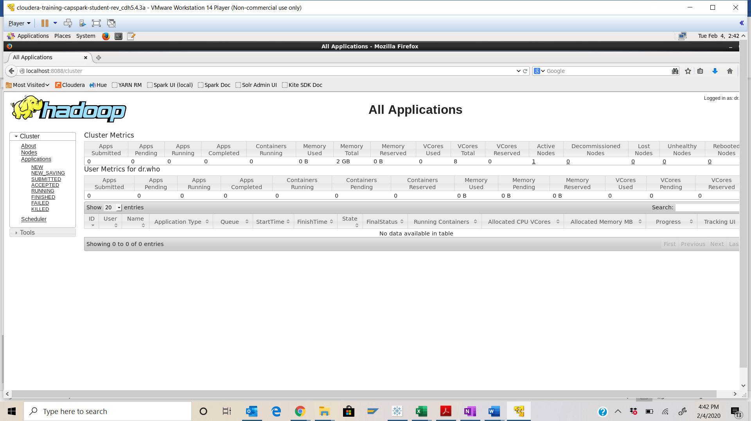

Step-3: Look at the cluster metrics section shown in the screenshot below.

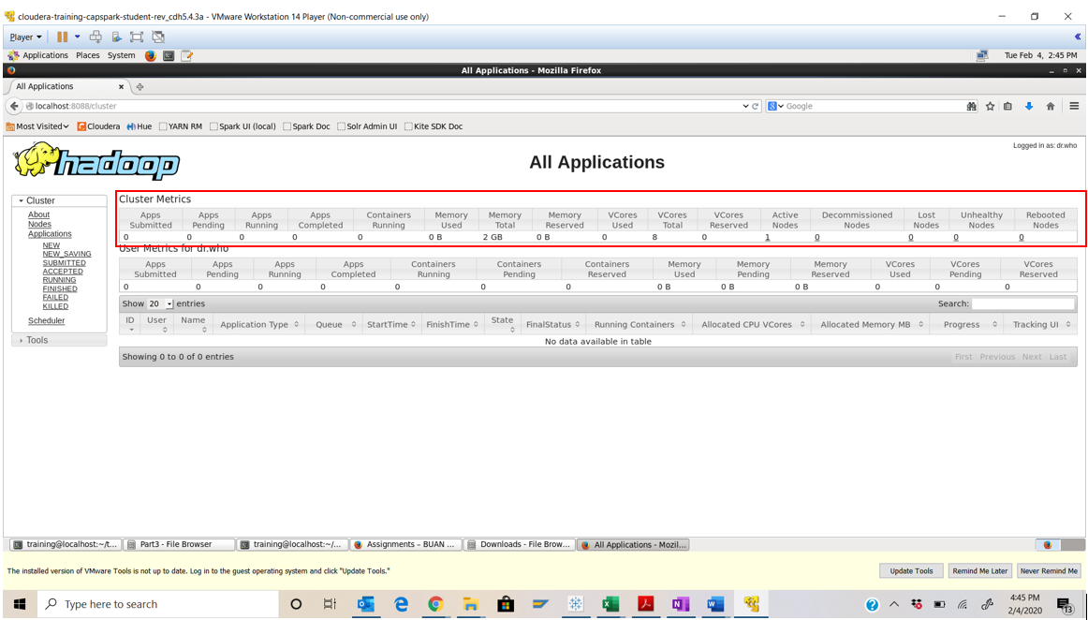

Cluster metrics provide a high-level view of YARN application execution. The metrics listed here are aggregated cluster-wide.

Step-4: Click on the node link in the cluster menu section on the left side of the screen as shown in the screenshot below.

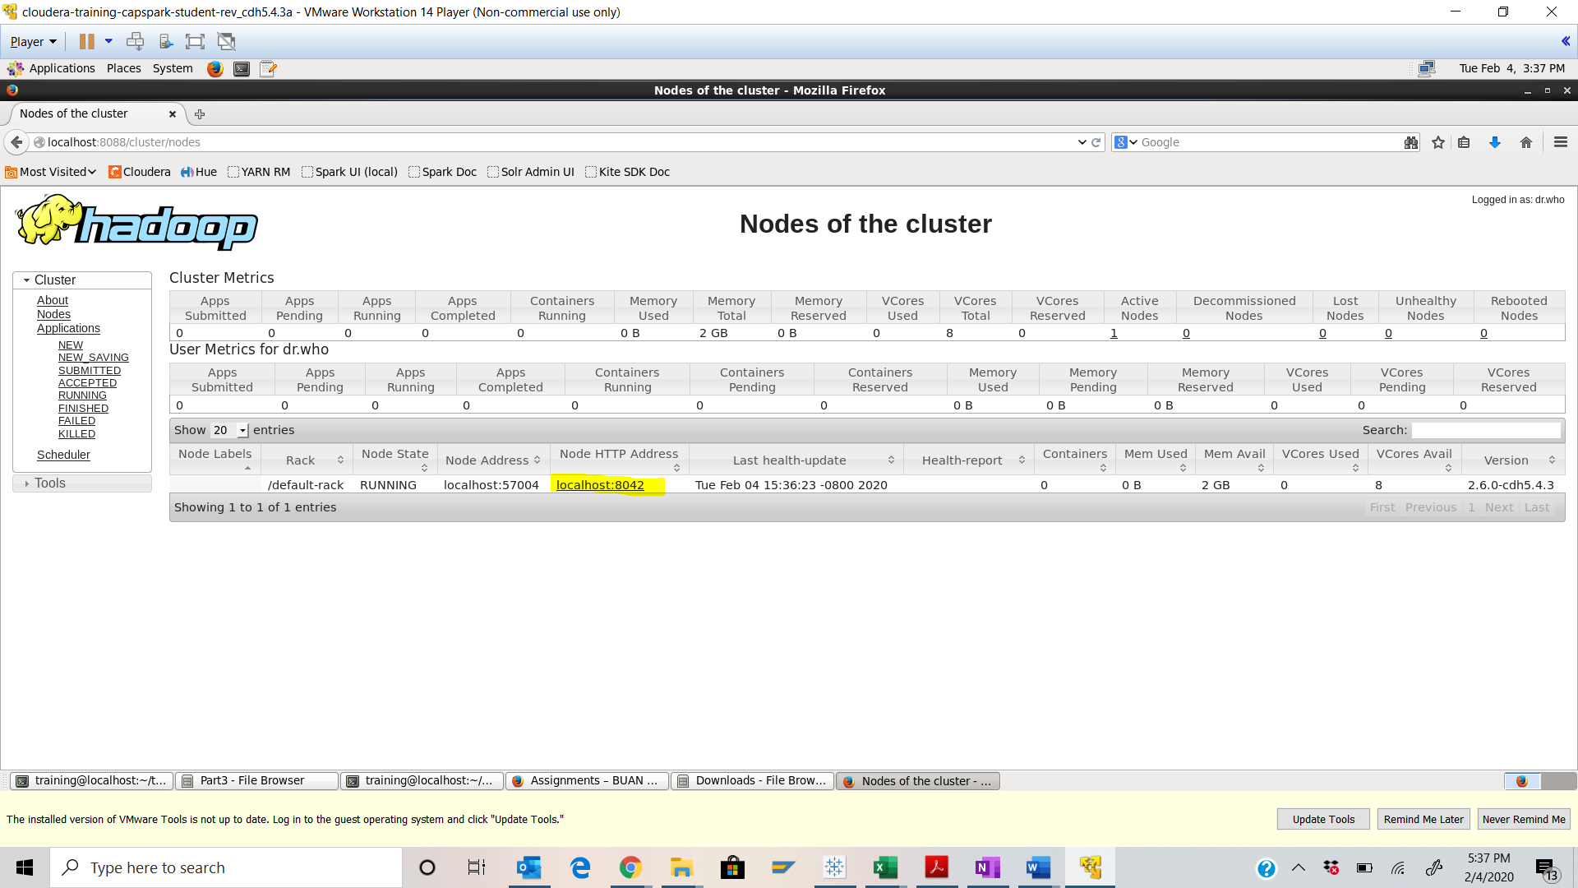

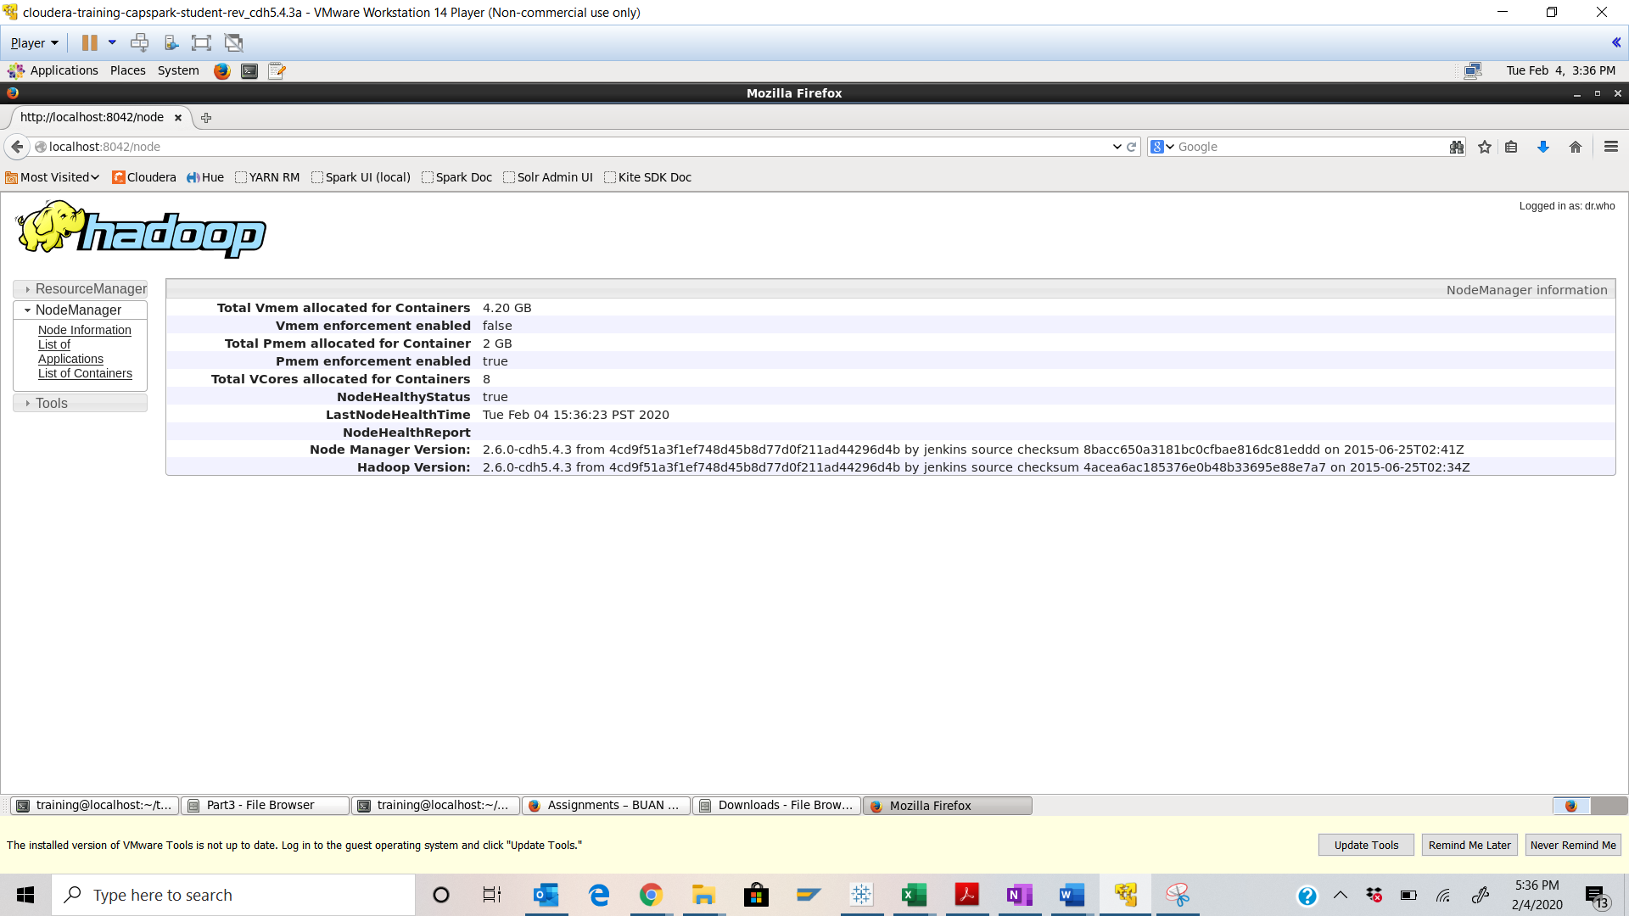

Step-5: Open another tab in the Firefox browser, open HUE and select the Job Browser button as shown in the screenshot below.

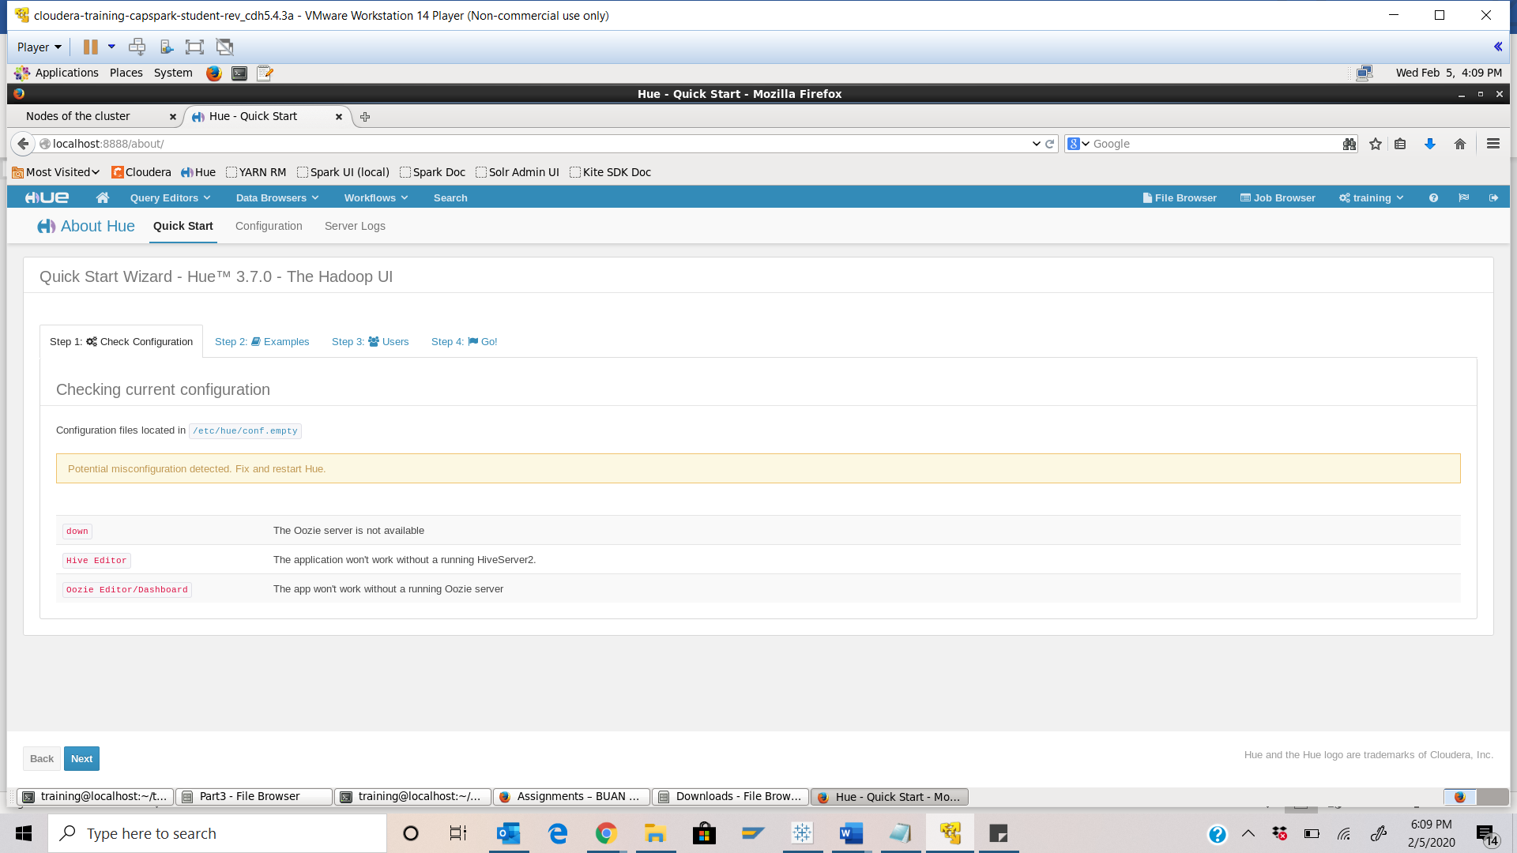

Part-2: Monitoring a Job in YARN and HUE: In this section we will simulate a Spark application, and view cluster specific metrics and job specific metrics using the YARN UI and Job browser in HUE while the application is running.

Step-6: Open the terminal application on the Cloudera VM desktop.

Q. Take a screenshot of the terminal application and paste it below.

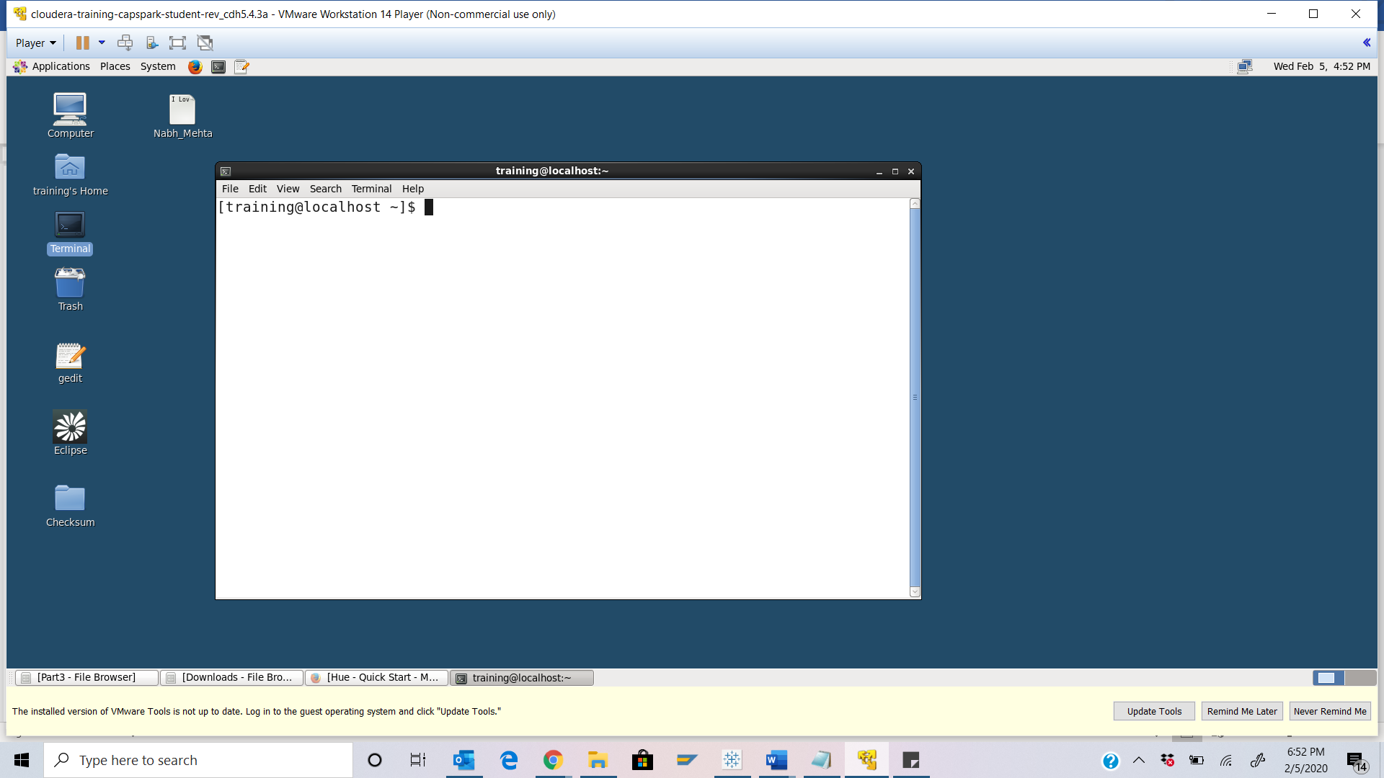

Step-7: Execute the following command at the shell prompt:





Q. Now type the command and execute. Take a screenshot of the shell output, highlight the wordcount.py file and paste it below.

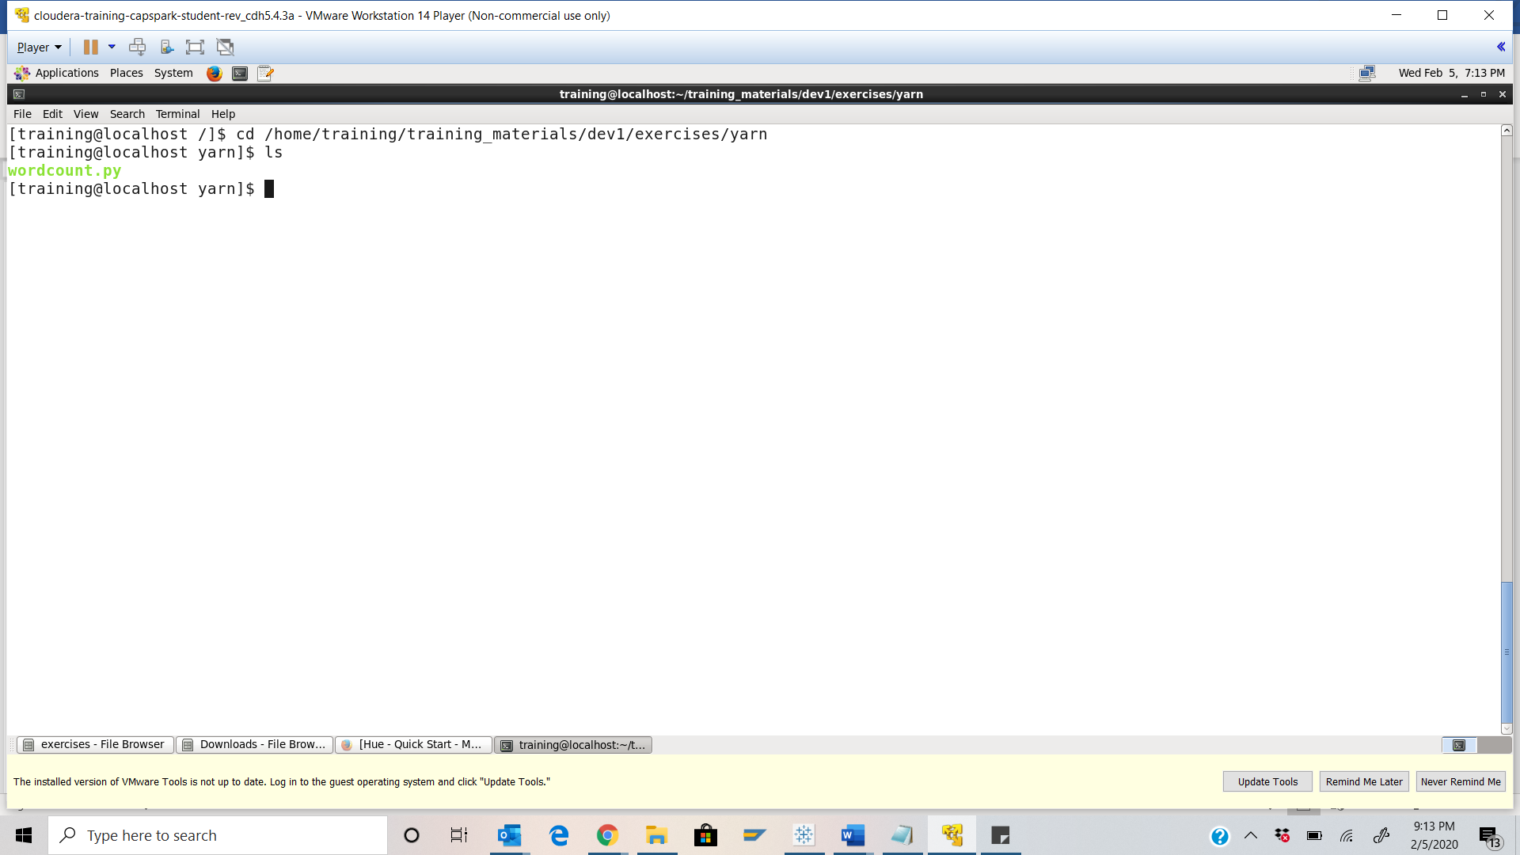

Step-8: Execute the following command at the shell prompt:

Q. Paste a screenshot of the shell output below.

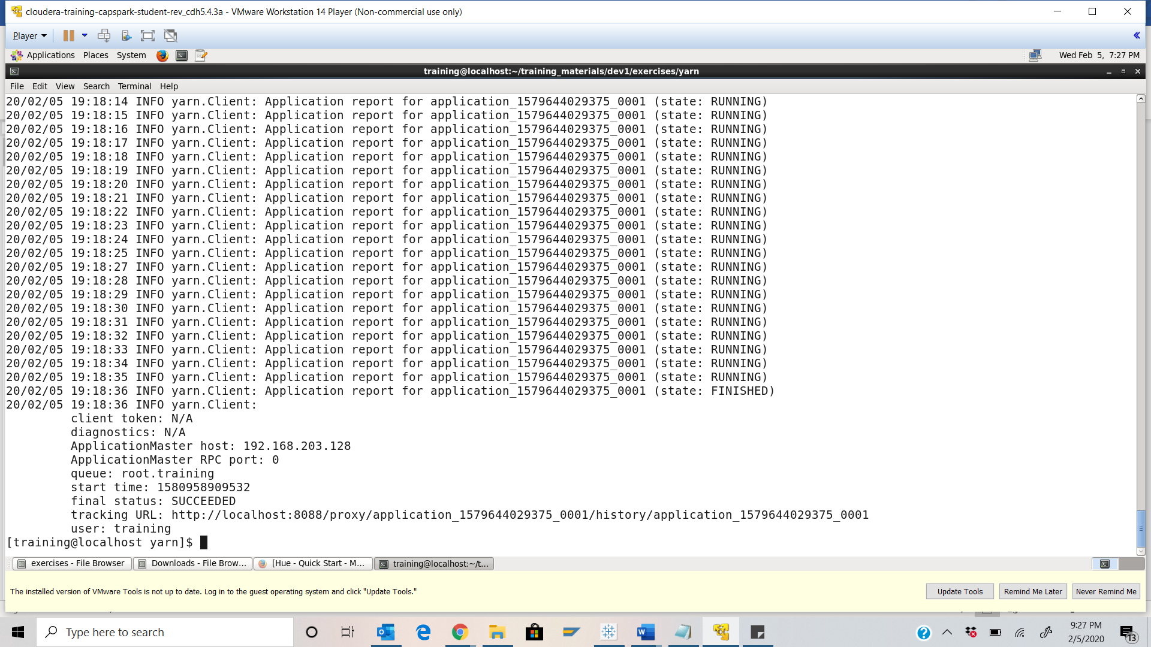

Step-9: Switch back to the HUE job browser and refresh the page.

Q. Take a screenshot of the Job Browser splash screen and highlight the job. Please type the ID and name underneath your screenshot.

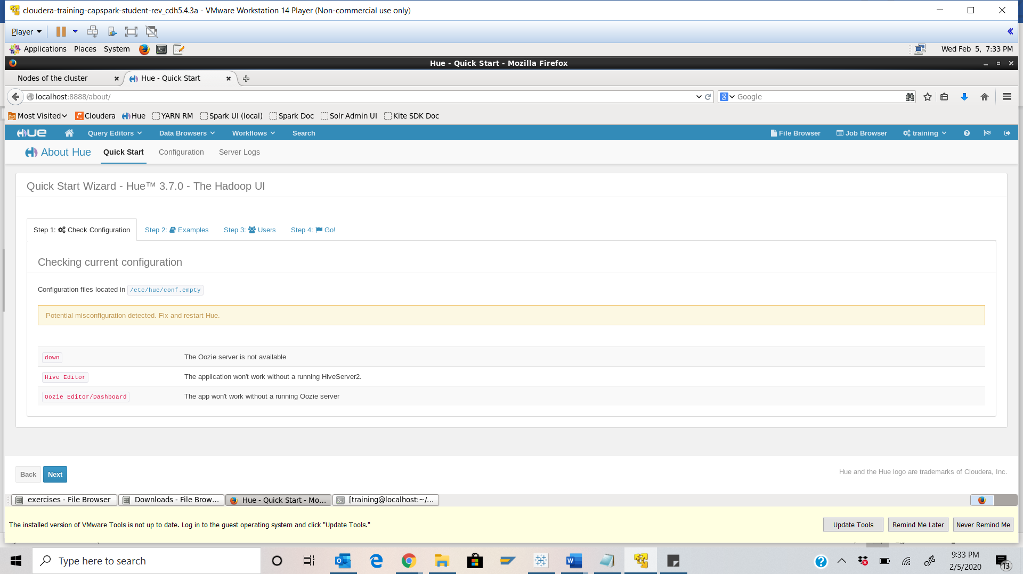

Step-10: Now switch over the other tab in Firefox that is running the YARN Resource Manager UI.

Q. Take a screenshot of the YARN UI screen and paste it below.

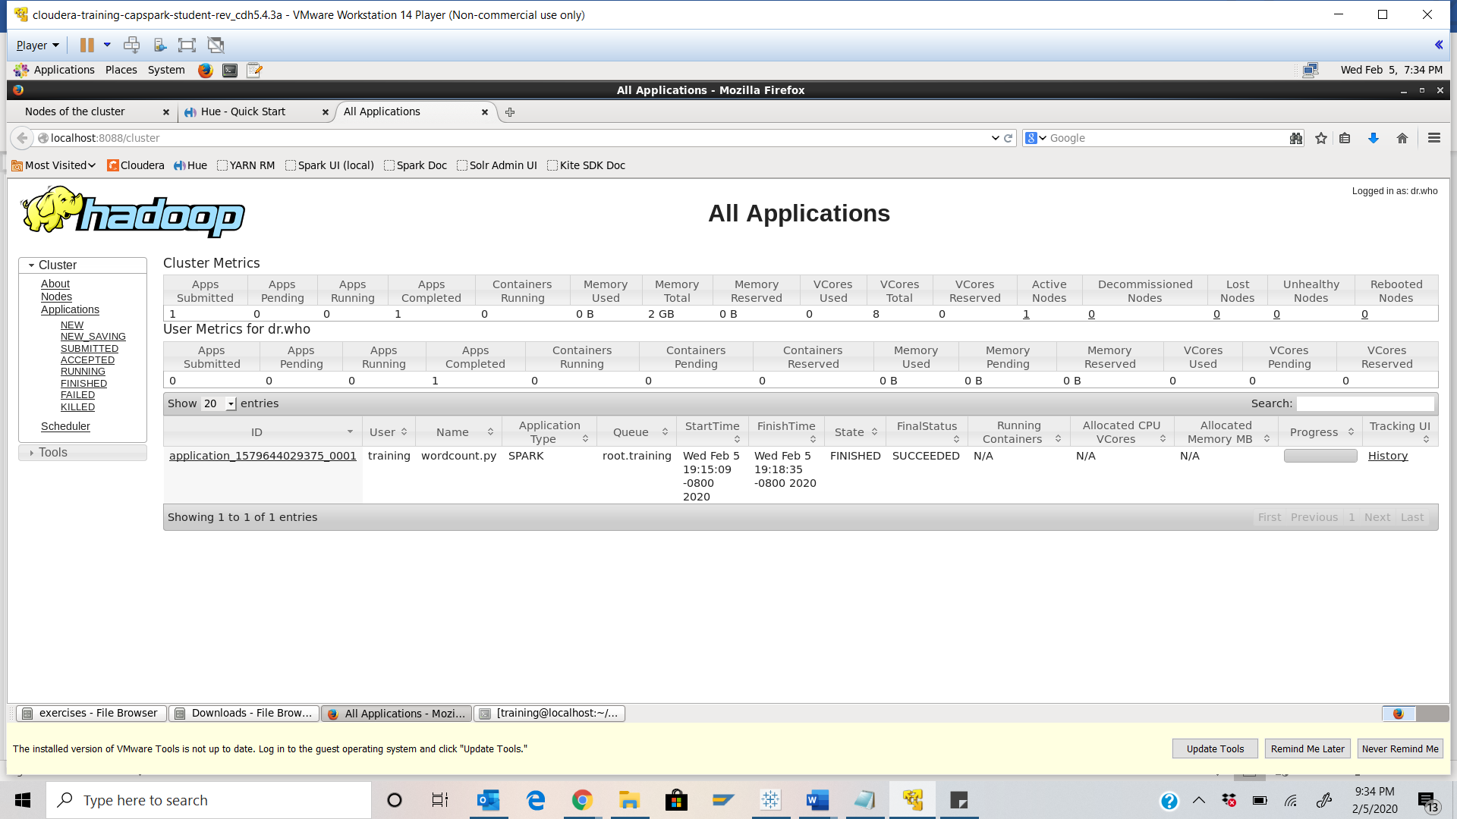

Step-11: Click on the Nodes link, like we did in Step 4. Click on the “Node HTTP Address” link highlighted in the screenshot below.

Q. Take a screenshot of the YARN UI screen and paste it below.

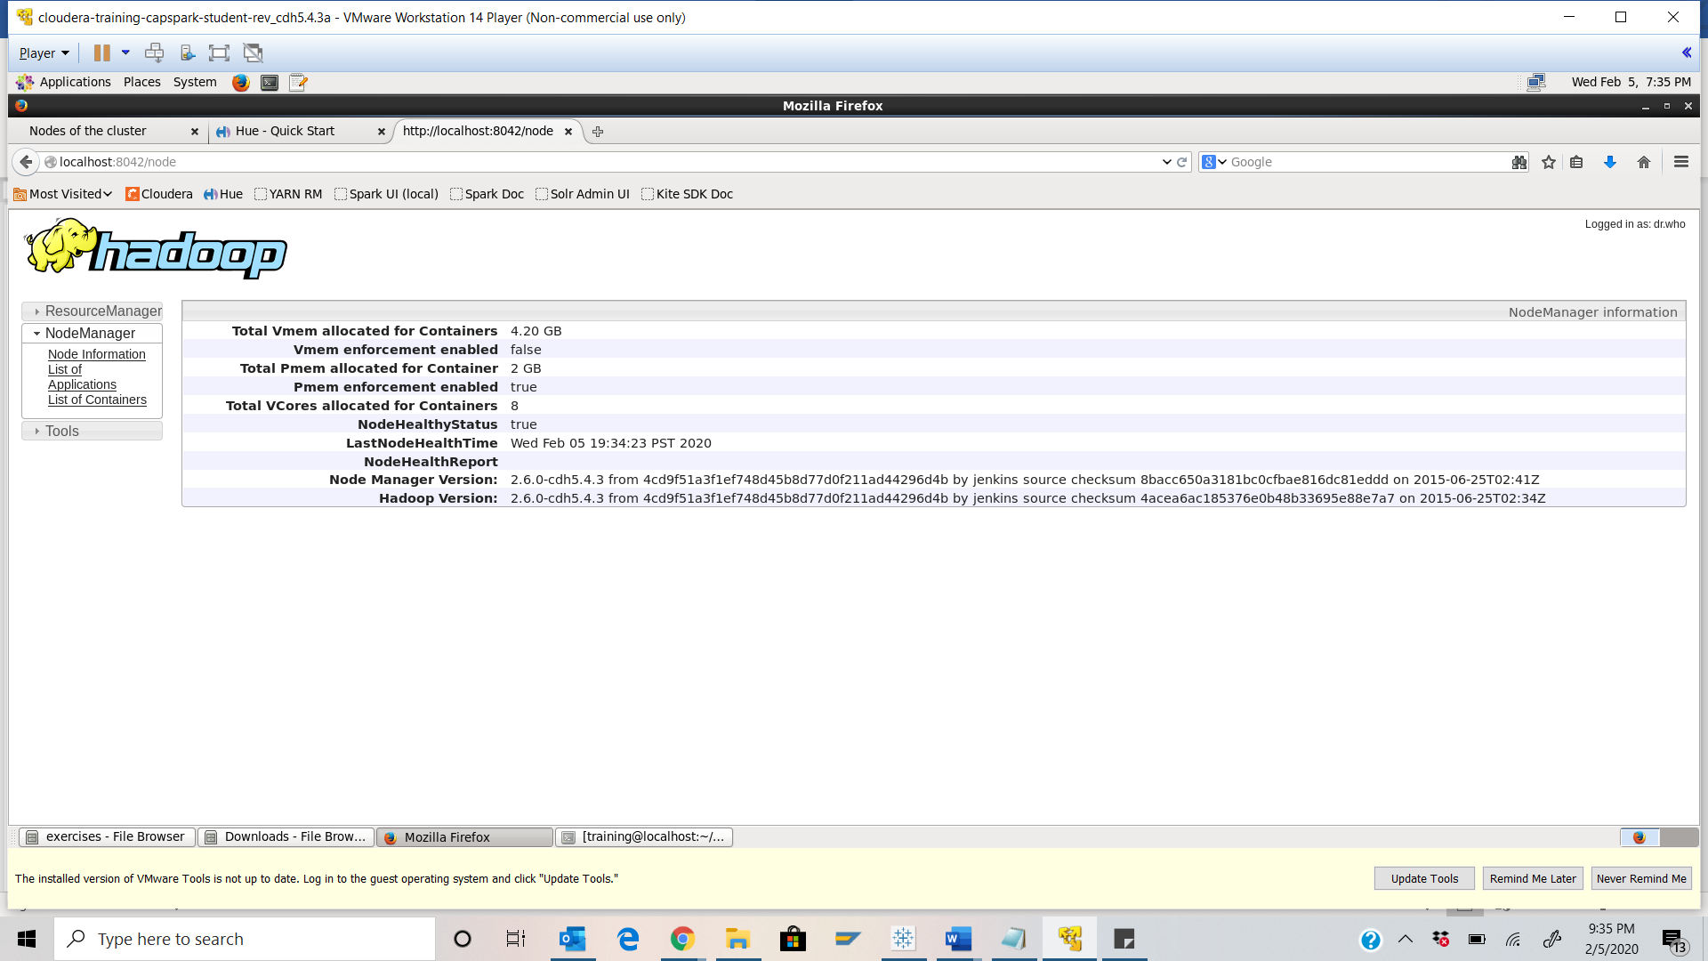

Step-12: Click on the “Applications” link in the Node Manager menu options on the left side of the screen as shown in the screenshot below.

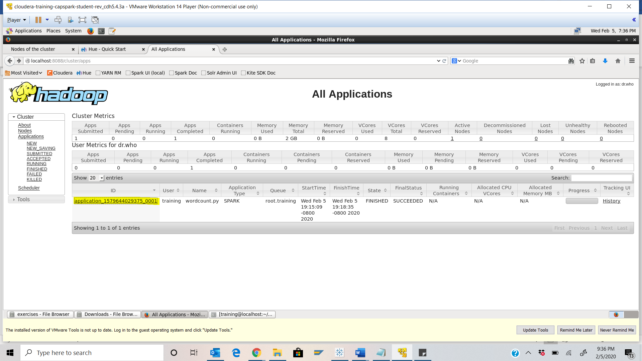

Step-13: Open a separate terminal window by clicking on “File” then “Open tab” as shown in the screenshot below.

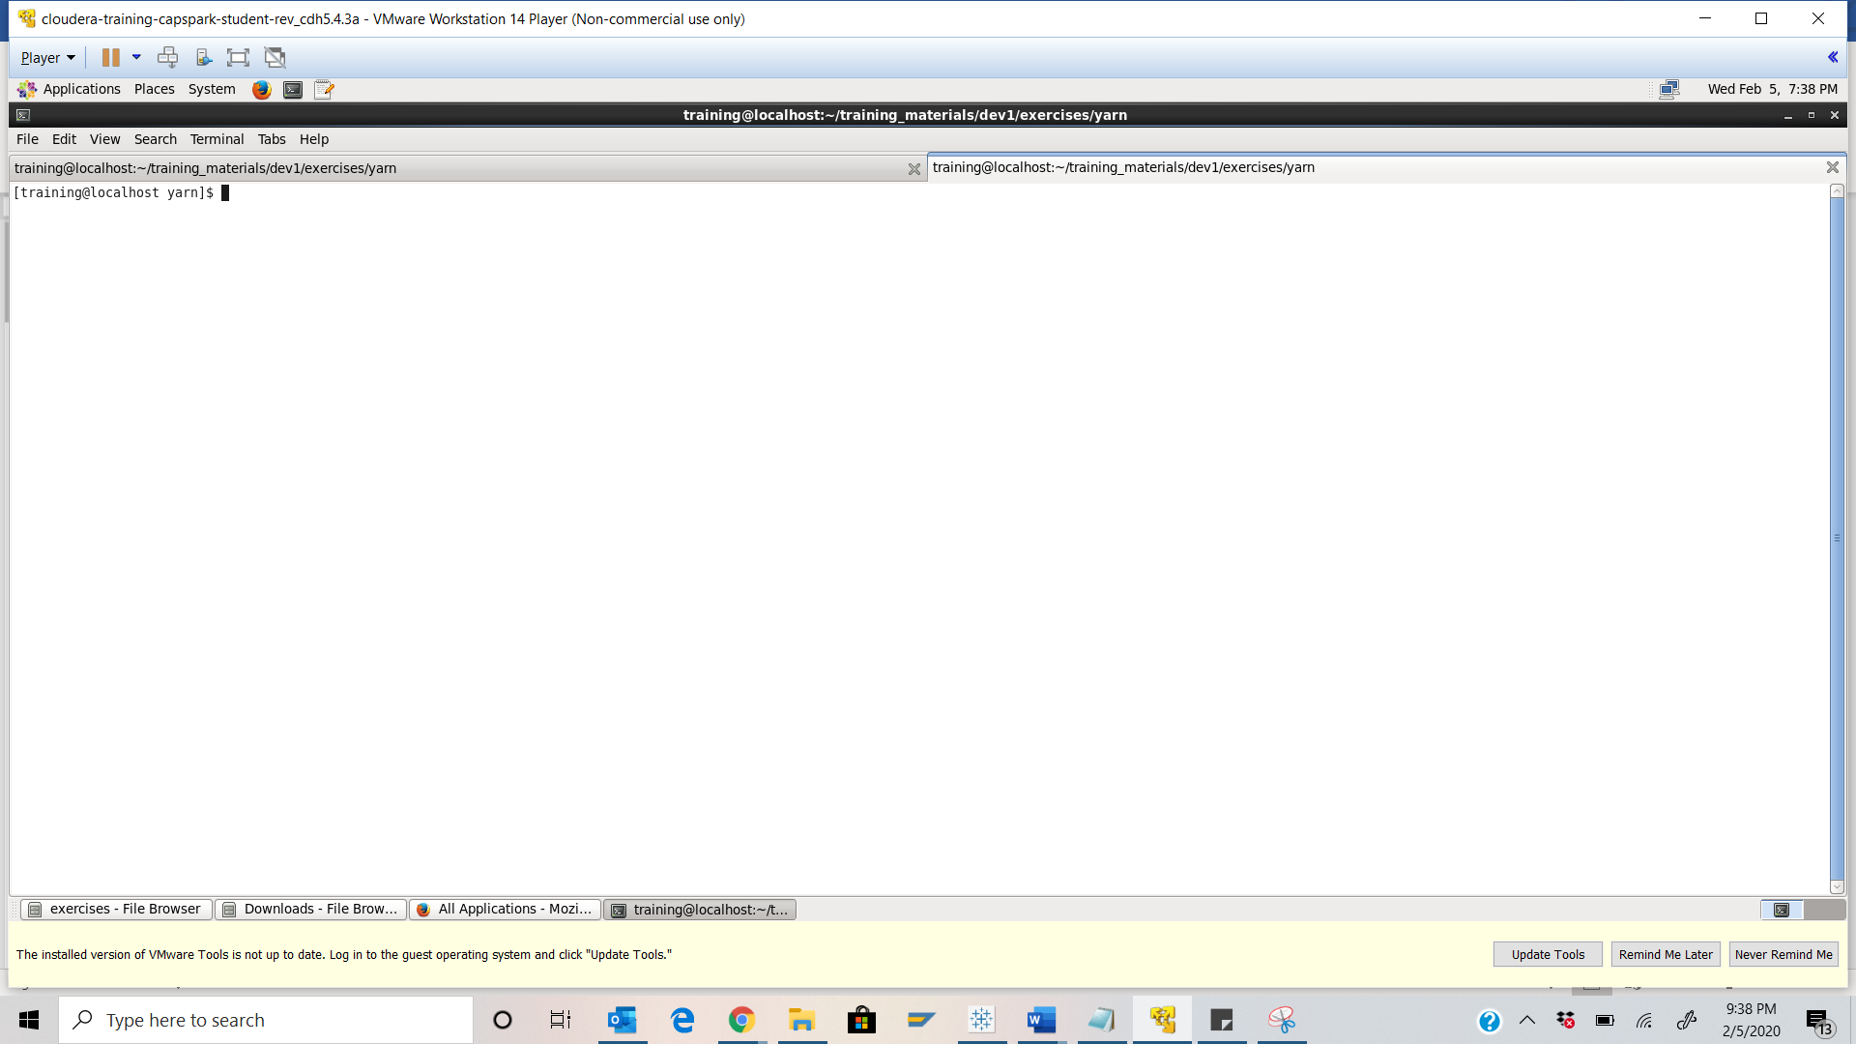

Step-14: Execute the following code at the shell prompt:



Q. Take a screenshot of the shell output and paste it below. Highlight the application ID.

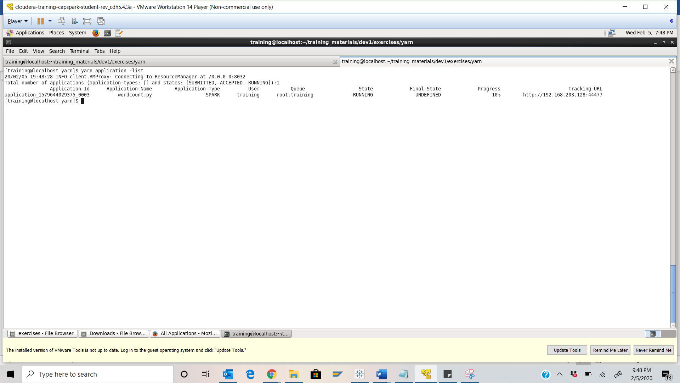

Step-15: Execute the following code at the shell prompt:



Q. Take a screenshot of the shell output after executing the following command and paste it below.



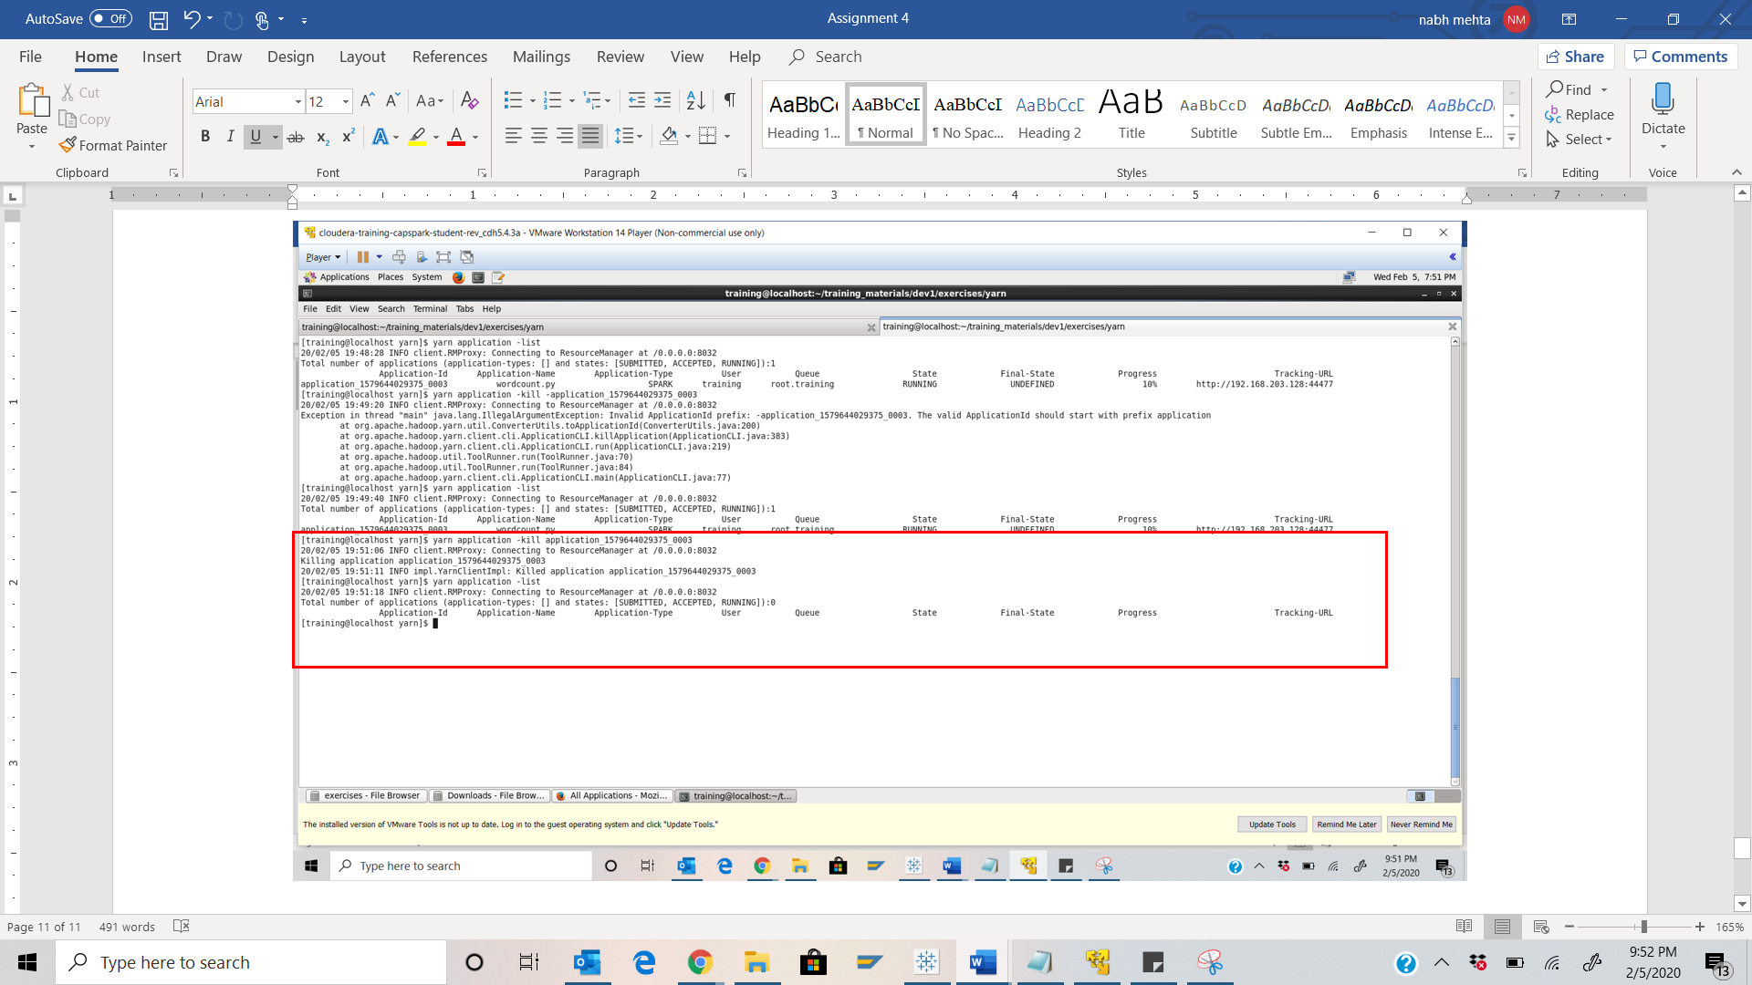

Part-3: Finding Help: This section will cover how to get additional information about YARN.

Step-16: The following link also provides additional documentation about HDFS filesystem commands.

<https://hadoop.apache.org/docs/current/hadoop-yarn/hadoop-yarn-site/YarnCommands.html>

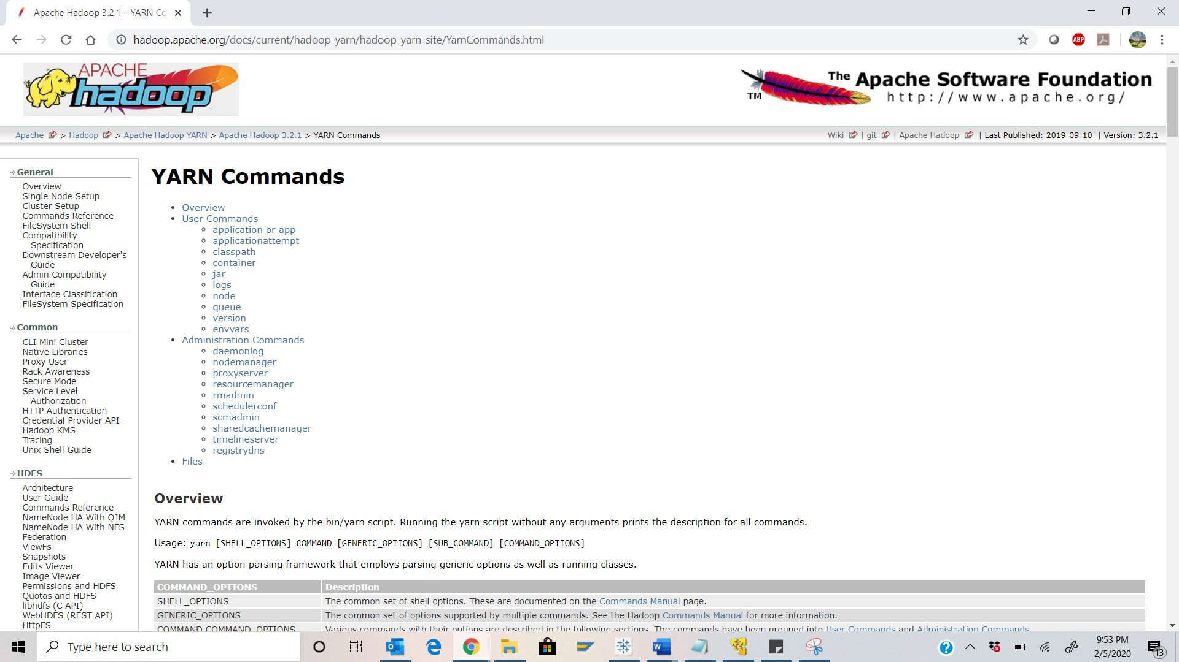

Part-4: Checksum: In this section we will perform a checksum

Step-17: Download the Checksum.zip file from eLearning into the downloads folder **IN** the Cloudera VM using Mozilla Firefox.

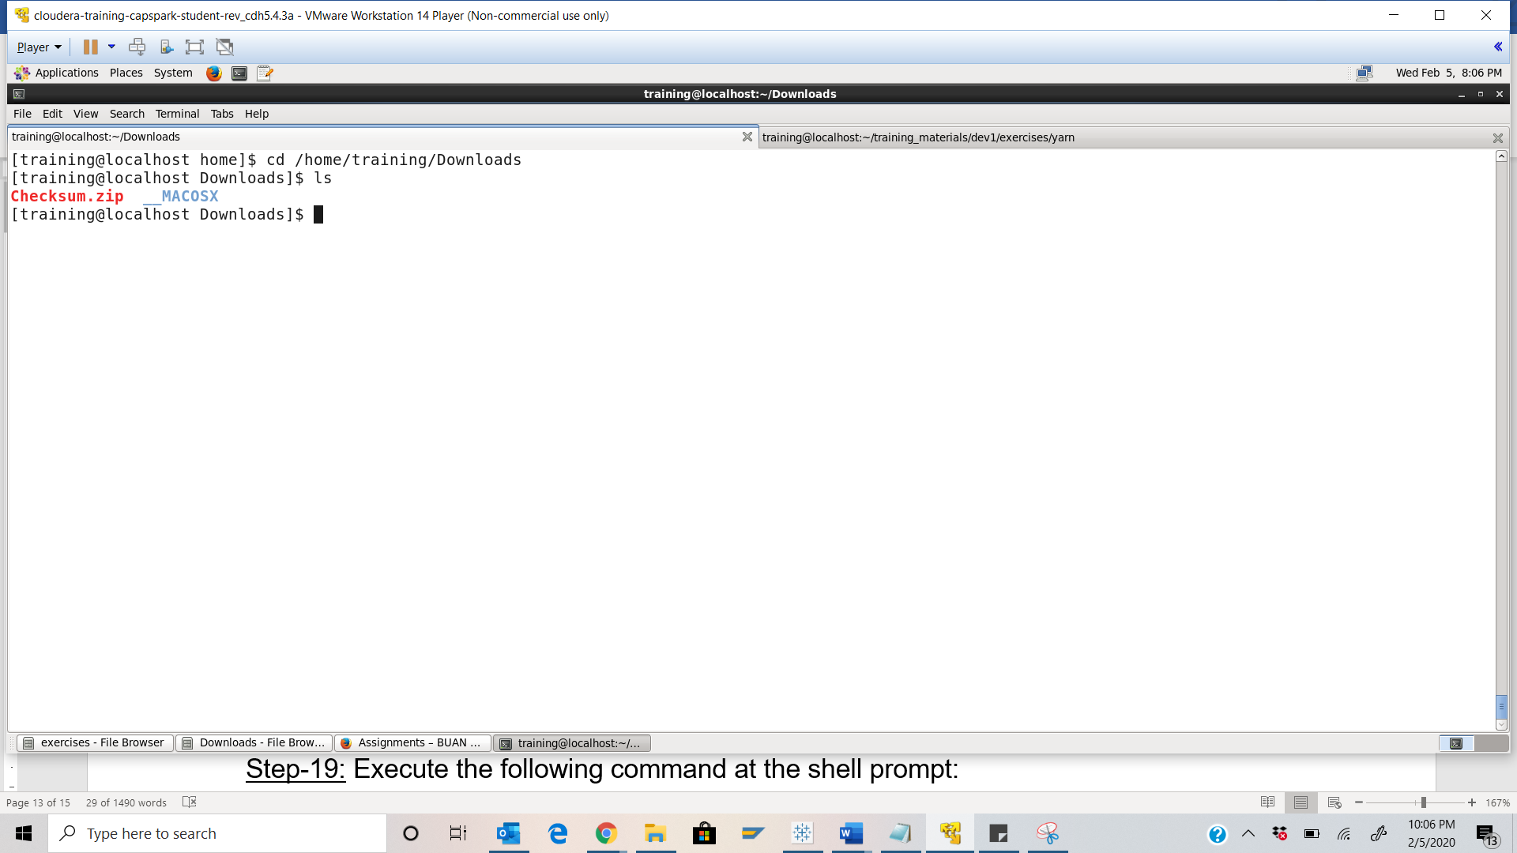

Step-18: Execute the following command:



Q. Now type the command and execute. Take a screenshot of the shell output, highlight the zip file and paste it below.

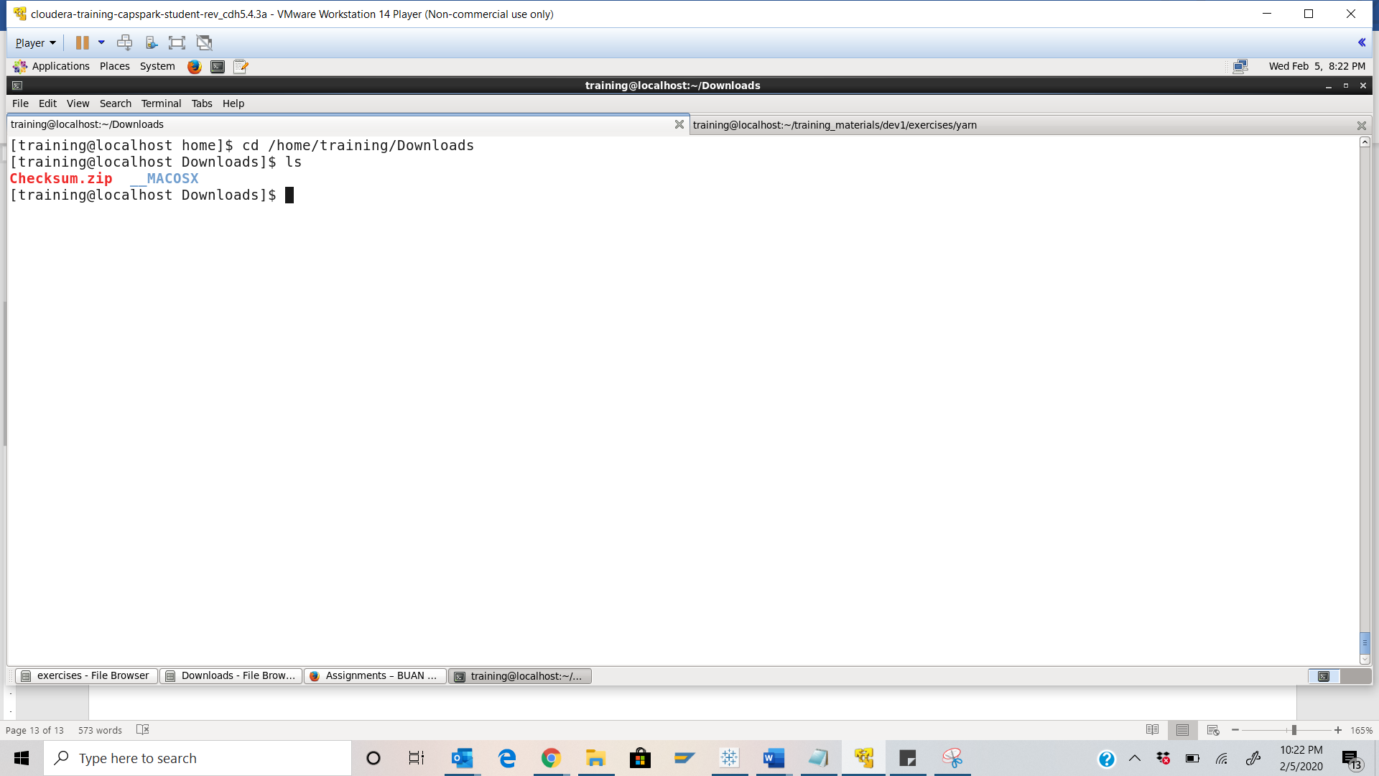

Step-19: Execute the following command at the shell prompt:



Q. Now type the command and execute. Take a screenshot of the shell output, highlight the contents of the zip file and paste it below.

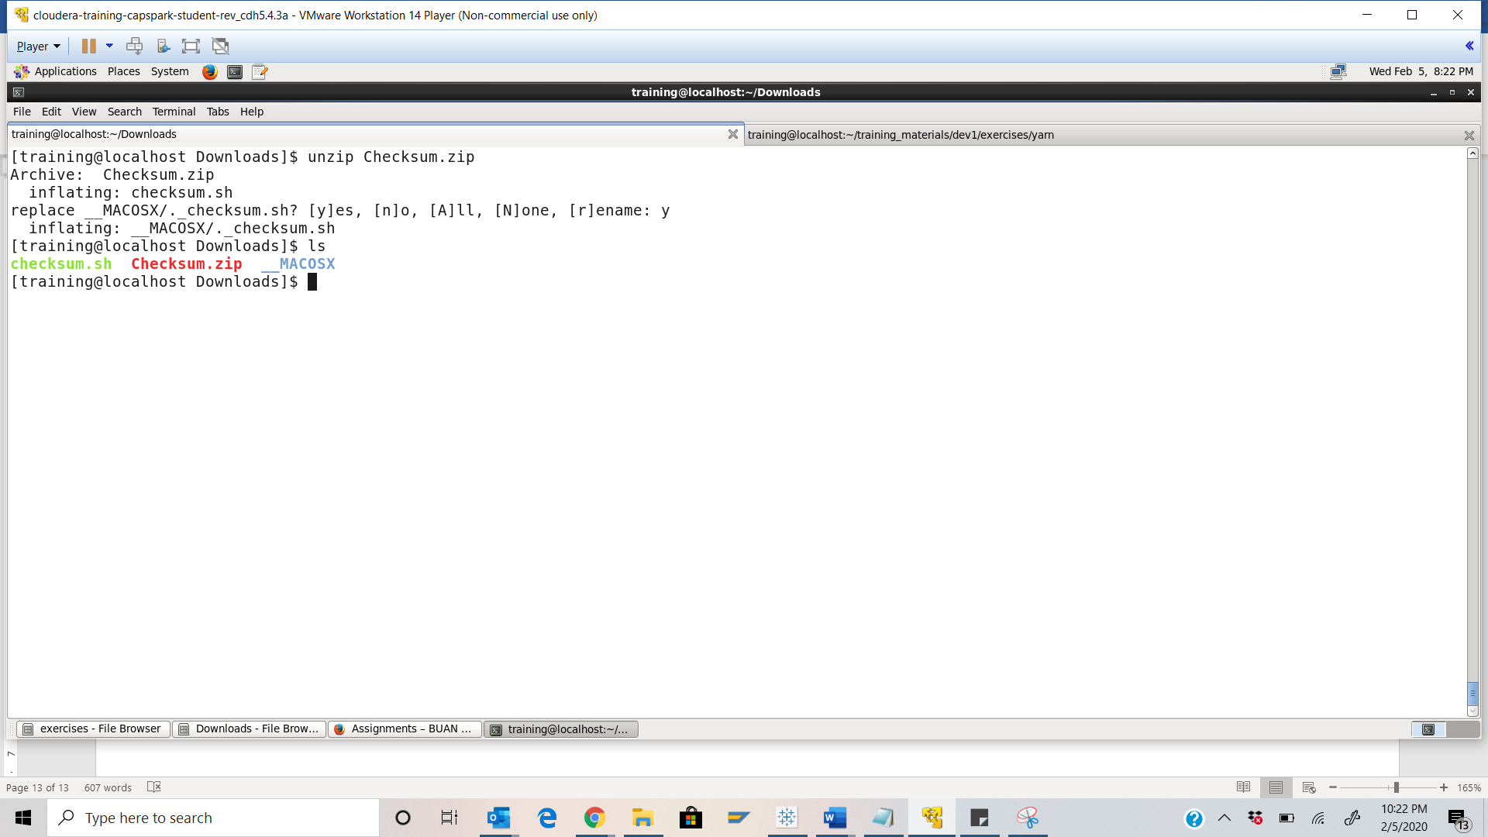

Step-20: Execute the following command at the shell prompt:

Then execute the following command:

Q. Take a screenshot of the shell output and paste it below.

Checksum Key - 6e3bd5bfcc35a23dddba7aa4a4213d86

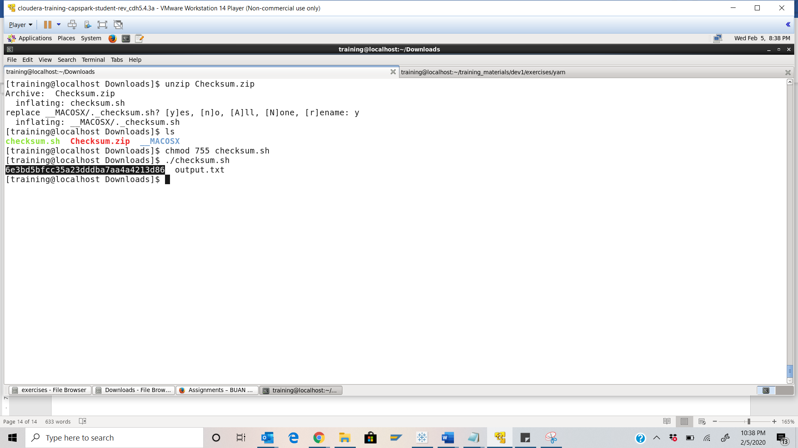

Step-21: Execute the following command at the shell prompt:





Q. Now type the command and execute. Take a screenshot of the shell output and paste it below.

